Experiential Learning: EPICS at the University of Auckland - Aims and Achievements of the First Two Years

Heather Silyn-Roberts, EPICS Auckland Director
Department of Mechanical Engineering, The University of Auckland, PB 92019, Auckland, New Zealand
(h.silyn-roberts@auckland.ac.nz)

Abstract: The programme EPICS (Engineering Projects in Community Service) was started in Purdue University in the USA in 1995. It is now run in 14 engineering faculties in the US and one in Puerto Rico. Last year the Faculty of Engineering at the University of Auckland began the first EPICS programme outside the North American area. It is creating great student and staff enthusiasm, together with media interest.

EPICS provides a curricular service-learning structure that enables interdisciplinary teams of students, together with faculty mentors and technical advisors, to work with community agencies that request technical help. The multi-year projects define, design, build, test, deploy, and support the systems that the agencies need. The results have a significant, lasting impact on the community organizations and the people they serve.

Learning outcomes for the students include: start-to-finish design experience; project management; client interactions and customer awareness; organizational and leadership skills; communication skills; teamwork; professional ethics; interdisciplinary experience; resource management; resourcefulness; and community interactions.

The current projects are: (1) The development of full three-dimensional virtual reality models of Maori and Pacific Island heritage artifacts in the Auckland War Memorial Museum. The models will be used for archival documentation, historical conservation, on-line exhibition and display, and replication. (2) Conversion of Waiheke’s waste cooking oil to biodiesel, and crushing glass bottles into sand. (3) Investigation at Auckland Zoo of water conservation and quality, and the construction of an educational, interactive installation that demonstrates the principles of hydro-electric power generation. A project with the Auckland Stardome Observatory, completed in one year, designed a system for automatic rotation and control of the Clark telescope dome and shutter.

This paper will describe the results of the first two years of EPICS at Auckland in terms of the diversity and achievements of its projects, together with the students’ learning outcomes.

Keywords: EPICS, experiential learning, service learning

1.0 Introduction
Aim of Auckland EPICS: To provide a curricular experiential-learning (or service-learning) structure enabling interdisciplinary teams of students at all levels of the BE degree to work with community organisations, on multi-year projects requiring a high level of engineering expertise and professionalism.

Accreditation criteria of many developed nations’ professional engineering institutions now require that students be given more than just a solid technical background (e.g., United States ABET Engineering Criteria, 2000). In the profession students will be expected to interact effectively in multidisciplinary teams with people of many different backgrounds to identify and achieve specific engineering goals, and also understand the clients’ needs. Moreover, they will need to be able to communicate effectively, and to understand a wide range of issues such as the implications of professional and ethical responsibilities, together with the global and societal impact of engineering. Engineering schools need to find curricular systems to satisfy these needs. At the same time, community service organisations are increasingly relying on the delivery, coordination, accounting, and improvement of the services they provide, and sometimes need the help of people with strong technical backgrounds. By combining these two sets of requirements it should be possible to provide student teams with a real-world experience often not available in other aspects of the curriculum.

EPICS (Engineering Participation in Community Service) provides a curricular experiential-learning structure that enables interdisciplinary teams of students, at all levels of the BE degree, together with faculty mentors and technical advisors, to work with community organisations that request technical help. EPICS projects define, scope, design, build, test, deploy, and support the systems that the organisations need; they can roll over a number of years, require a high level of engineering expertise and professionalism, and are managed by the student team. The results have a significant, lasting impact on the community organisations and the people they serve.

Learning outcomes for the students include: start-to-finish design and deployment experience; project and personal management; client interactions and customer awareness; organisational and leadership skills; communication skills; teamwork; professional ethics; interdisciplinary experience; resource management; resourcefulness; and community interactions (Coyle et al., 2006). EPICS National co-director William Oakes (2005) has noted that research has shown that service-learning can enhance classroom learning; is consistent with theories for increasing retention ; and the community context and social relevance is consistent with the characteristics advocated to increase participation of minorities in engineering, particularly women. Since all of these are supported with respect to EPICS only by strong anecdotal evidence, there is now an urgency to collect hard data in this area (Oakes, 2006), particularly with regard to its importance in obtaining corporate funding (Spencer, 2006).

The programme EPICS (Engineering Projects in Community Service) was started in the Department of Electrical and Electronic Engineering at Purdue University in the USA in 1995 (Coyle et al., 2006). It is now run in 14 engineering faculties in the US and one in Puerto Rico. Last year the Faculty of Engineering at the University of Auckland initiated the first EPICS programme outside the North American area. It is creating great student and staff enthusiasm, both here and in the US, together with media interest. The Auckland programme differs in various significant ways from the North American programme, in particular in that it is not locked into the design syllabus as in the US, in the student composition of the teams, and in the assessment processes.

2.0 Structure of the programme
The Auckland programme is made up of a director, together with an academic mentor for each team of students, and technical advisors if needed. The team operations are managed entirely by the students. There are no set hours in the EPICS programme, but most teams have a weekly team meeting together with the mentor, and the client if available.

A significant feature of EPICS programmes is that the teams are interdisciplinary and moreover involve students from all years of the degree programme. The North American programmes are designed so that students at all levels - from first to final year - gain credit. Although this is desirable and something that we are working towards, our timetable prevents it. Consequently our programme enrols final-year students for credit into a specified paper and invites students from all other levels of the degree to take part voluntarily. One academic mentor in 2006 has selected voluntary students on the basis of the specific competencies they would bring to the project; the others have accepted anyone who volunteers. In 2005, there were 17 credit students, together with 14 voluntary students; in 2006: 22 for credit and 23 voluntary.

3.0 Assessment
Assignments are designed to be similar to the standard deliverables of a large engineering organization. A high level of professionalism is expected.

40% of a student’s final mark is contributed by his/her individual grade as assessed by the mentor, and 60% from the teams’ grade. Some elements of the team’s work is assessed by only the mentor, some by both mentor and client. The elements of the assessment are shown in Table 2, and are described more fully in Appendix 1.

Table 2: Summary Table of assignments
 | % | Assessor
Inputs to the team grade
Project proposal | 5 | The mentor & client
Mid-year progress report | 10 | The mentor
End of year team presentation | 10 | The mentor & client
Final report (two sections: non-technical and technical) | 30 | The mentor & client
Assessment of team’s performance | 5 | The mentor & client
Total | 60%
Inputs to the individual student's grade
Assessment of individual student’s performance by the mentor, including individual student’s peer evaluation and self-assessment, together with short interview with the mentor. Each semester. | 2x20 | The mentor
Total | 40%

4.0 EPICS projects in 2005 and 2006
Possible clients are identified and contacted by the director; specific projects are determined by discussion with the organizations’ relevant staff. The director ensures that all projects involve relevant engineering work requiring a high level of knowledge and professionalism.

Five projects were started in March 2005. Of these, four have rolled over to 2006, and one was completed in one year. A further project was started in March 2006. All projects are summarized in Table 1 and are described more fully below.

Client and projects | 2005 | 2006
Auckland War Memorial Museum  Development of full, culturally accurate three-dimensional virtual reality models of Maori and Pacific Island heritage artifacts |  | Initiated
Waiheke Waste Resource Trust  Project 1: Conversion of waste cooking oil to biodiesel  Project 2: Conversion of glass bottles to sand | Initiated  Initiated | Continuing  Continuing
Auckland Zoo  Project 1: Design and construction of an educational, interactive installation demonstrating principles of hydro-electric power generation.  Project 2: Investigation of water conservation and quality, and deployment of a sustainable water management plan. | Initiated  Initiated | Continuing  Continuing
Auckland Stardome  Design of a system for automatic rotation and control of the Clark telescope dome and shutter | Completed in one year

The projects are described here in some detail to illustrate the high level of engineering involved and the achievements to date. Both of these aspects have been commented on very favourably by EPICS National co-directors and other personnel involved in EPICS projects.

Project 1. Started 2006: Client - Auckland War Memorial Museum
Aim: To develop culturally accurate three-dimensional virtual reality models of Maori and Pacific Island heritage artifacts held in the Museum collections, using 3-D digitizing tools to capture the full three-dimensional geometry and surface detail. The Museum will use the models for archival documentation, historical conservation, on-line exhibition and display, and replication. Since many Maori and Pacific Island artifacts are composed of fragile organic materials such as cloth, feathers, twine, and wood, it is a challenge to the technology to render detail by laser digitization, and also to avoid degradation of the material. This year’s project has been aimed at setting a foundation for future years’ EPICS projects with the Museum.

The initial phase of the project has been made up of comprehensive research into the varying methods of digitising artifacts, by investigation of the use of either a laser scanner based on triangulation or one that combines photogrammetry and triangulation. The team has recommended the MVT scanner; this is capable of capturing an object’s geometric data with a minimum accuracy of +0.1 mm and will be configured to run with the post-processing software, which will align, mesh, render, and present the point data as a solid 3D model.

The team has already developed a process for scanning Museum artefacts using the existing Polhemus FastSCAN laser scanner at the Bioengineering Institute. Artefacts made from various materials have been digitized: wooden artefacts such as a replica of the statue of a Tongan Goddess, a replica of a wooden flute, and an original canoe prow found in the Sepic River in Papua New Guinea(Figure 1); a whalebone kotiate (bludgeon); and a stone adze. The data points stored in IGES format are imported into RapidForm 2006 software. Post-processing involves triangulating the point cloud data to build a polygon surface model using generic surface creation tools such as blending and N boundary filling.

The team is made up of three subgroups: the scanning team; the post-processing team; and a research team that is writing a business proposal for the purchase of the MTV scanner.

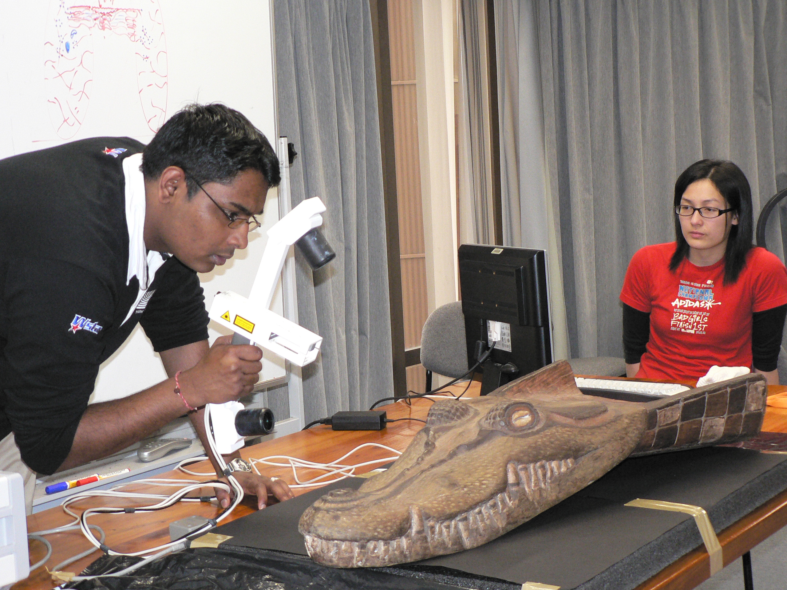

Figure 1 EPICS Auckland Museum project: laser digitisation of an original Papuan canoe prow in the form of a crocodile head.

Notable feature of this project
In August 2006 the academic mentor of this project, Dr. Xun Xu of the Department of Mechanical Engineering, and Dr. Oliver Stead, Head of Collection Management at the Auckland Museum, were awarded $95,200.00 by the government’s Community Partnership Fund to support this work. EPICS involvement in this project was a key factor in the bid’s success. The Community Partnership Fund is a contestable fund aimed at Information and Communication Technology (ICT) projects, and is part of the government’s Digital Strategy.

Waiheke Waste Resource Trust

The introduction of commuter fast ferry services to Waiheke has caused major development, with resulting problems of waste disposal. EPICS is working on two projects with the Waiheke Waste Resource Trust (WRT), a non-profit community organization, together with Waiheke Clean Stream, which deals with waste collection and the Waiheke Transfer Station.

Project 2: Started 2005: Waiheke Waste Resource Trust: cooking oil-to-biodiesel team

Aim: WRT currently ships two tons per month of waste cooking oil off the island to Auckland at a cost of $25 per 40-gallon drum. The aim of the project is to convert the oil into biodiesel and assess its characteristics, to install a process plant on the island, and to use the biodiesel produced on site to run some of the machines operating at the Transfer Station.

In 2005, waste cooking oil was converted to biodiesel using a base-catalysed transesterification process. Preliminary engine testing was performed in the Lister engine in the Department of Mechanical Engineerining’s Energy and Fuels Research Unit (Figure 2). Density measurements indicated that it was within ASTM standard specifications.

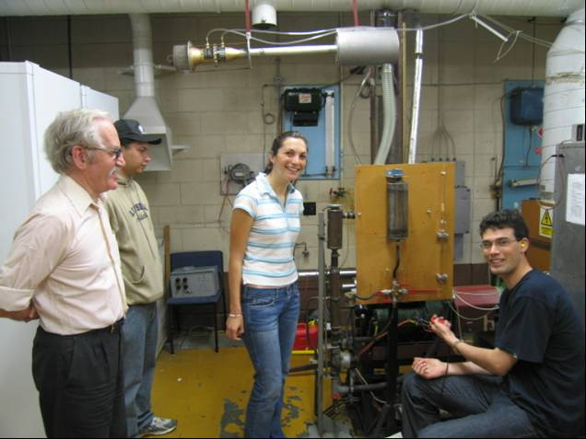

Figure 2 EPICS Waiheke Waste Resource Trust project: testing in a Lister diesel engine of the biodiesel produced from waste cooking oil

The 2006 team has pursued manufacture of biodiesel and varied the conditions of washing, filtration and catalyst to ensure a standardised process. They will shortly do a GC analysis of the biodiesel. They expect to develop a process flow diagram by the end of the year together with a prototype design. The plant design specifications include ensuring that the plant is operator-friendly, safe, mobile, and of an appropriate scale to convert two tons per month at the Waiheke transfer station. The plant design will incorporate an analysis of the final plant construction together with an economic study.

Notable features of this project
The biodiesel project has been very enthusiastically supported by the co-directors of the US-wide National EPICS programme, and has been featured in their presentations to the American National Academy of Engineering. It also generated much media interest in New Zealand in 2005 and has resulted in continuing queries by interested parties.

Project 3: Started 2005: Waiheke Waste Resource Trust: bottles-to-glass team

Aim: WRT currently spends $20,000 per month on shipping bottles off the island for recycling in Auckland. The Epics team aims to produce sand by crushing glass bottles; to research possible uses for the sand; and to install a small-scale process plant on the island.

In 2005 methods of crushing and label removal were tested. Sand of various grades (>2.3, 1.7, 0.85, 0.6, 0.3 and <0.3 mm) was produced in a jaw crusher, and glasscrete tested.

In 2006 the team has focused on comparing different types of crushing equipment to establish which one is best suited to the Island's needs. The team has also crushed glass using equipment in the Civil and Environmental laboratory and the Rocktec rock-crusher in Matamata. It was found that the labels, which were thought to be the main contaminant, can be separated from the crushed glass simply by the sieving process. The main concern shifts to the plastic labels and food contaminants as they tend to build up and clog the crusher. Another complication found was that a considerable amount of crushed glass below sand particle size produced after crushing, which gave rise to dust. This means that the team may have to incorporate dust control system in the plant design.

The team has recommended the purchase of a Hammer Mill. They are also currently examining screening equipment for the production of the three required grades of glass, together with methods of containment of the dust produced, and methods of determining the specifications of the glass. They expect to finish the design of a process plant by the end of the year. They have also considered alternative uses for the crushed glass since last year’s team focused mainly on using the crushed glass as mixture for concrete.

Project 4: Started 2005: Auckland Zoo: power generation team
Aim: to design an educational, interactive installation that demonstrates the principles of hydro-electric power generation.

The 2005 team investigated the feasibility of onsite sustainable generation of electricity to act as a back up power supply for the newly created frog enclosure. The team found that the primary renewable source of energy onsite (hydro) was unsuitable for the enclosure’s power requirements of 22kW, owing to the insufficient level of mass flow within the zoo waterways.

The current aim is to design an educational resource for the zoo to demonstrate hydro-power generation. The largest challenge facing the project, given the high degree of flow variability in the river, is that the waterwheel must withstand the large fluid forces whilst still remaining viable at low flow situations.

This year’s team has analysed current global uses of waterwheels; analysed the effect of channelling the flow and the potential power available at minimum flow levels; used Pro-Engineer to develop an accurate CAD model of the environment; developed a Computational Fluid Dynamics (CFD) mesh modeling simulation of the flow using CFX software, and from it, established the optimum region to mount a waterwheel; and investigated resource consents. The team has concluded that the modeling work shows potential for developing a creative and workable solution to satisfy the requirements of the Auckland Zoo.

Project 5: Started 2005: Auckland Zoo: water conservation team
Aim: Auckland Zoo is the main user of water in the Auckland region. The overall aim of the EPICS team is to improve the water management system at the Zoo.

Water from Western Springs is fed into the zoo to become Hippo River, which flows sequentially through the lion, flamingo, baboon and hippo enclosures. The hippos are the main contributors to water quality degradation. The water then exits the river system and is released into an Auckland creek.
There are no data on either water quality or flow. The team is investigating flow volumes within the river and the variation in water quality along the length of the river, with the aim of establishing whether water treatment could enable Hippo River to be recirculated. It is also working with Auckland Regional Council to determine the quality requirement for water exiting the zoo.
The team has continued the water quality testing started in 2005 and confirmed results with independent testing at a contract laboratory (Figure 3).

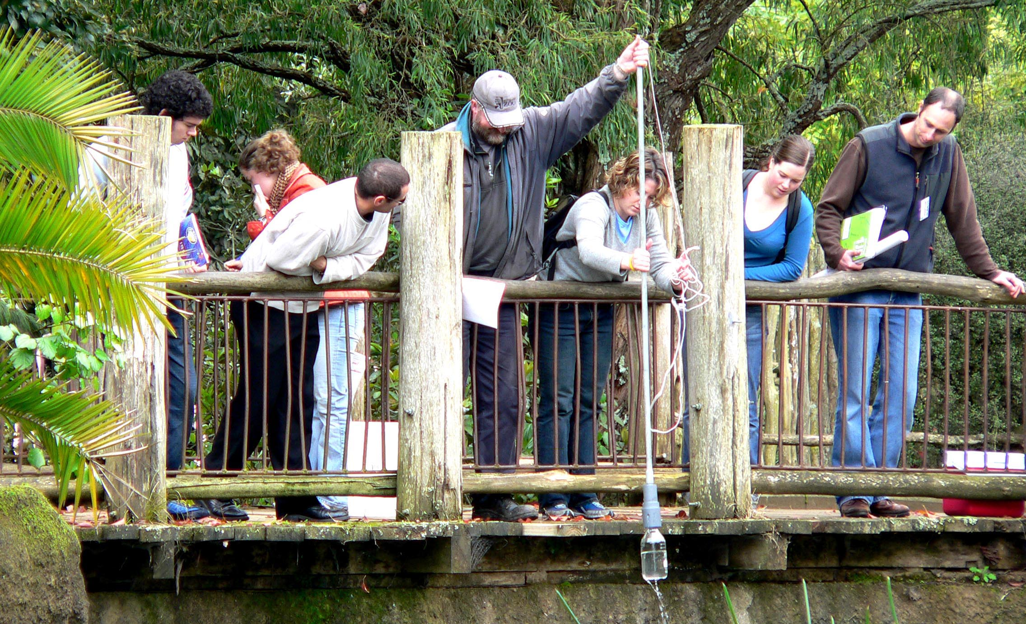

Figure 3 EPICS Auckland Zoo project: water quality testing of Hippo River

The work begun in 2005 on "mudballs" (effective microorganisms) as a water purification method has been continued by this year’s team. Various mudball configurations are currently being tested for effectiveness in improving the quality of water collected from the double hippo enclosure. Concurrently the team has continued investigating alternative types of treatment required, and are also doing a feasibility investigation of pipe network and facilities to create a recirculation scheme within Hippo River.

The team has also performed a thorough feasibility investigation of using wetlands to treat water flowing through animal enclosures, including calculations estimating wetland size. It has been concluded that this will not be a feasible option.

Project 6: Auckland Stardome Observatory Started and completed in 2005
Aim: The design of a system for automatic rotation and control of the Clark telescope dome and shutter.
The system as designed by the students was accepted by the client and will be incorporated into new development at the Stardome.

5.0 Student learning outcomes
A notable feature of the Auckland EPICS programme has been the enthusiasm with which students have become involved in the projects, reflected in the amount of time that they have spent, bearing in mind that the teams organize their own work and that there are no fixed lecture or tutorial periods. The average amount of time spent by credit students in the first semester of 2006 has been 50-60 hours over 12 weeks, with more time being spent prior to the submission of assignments. Moreover, voluntary students have been remarkable for the persistence of their enthusiasm throughout the year. The written comment of one client underlines this: ‘Be prepared to protect the students from their own enthusiasm. It is important for them to remember that EPICS is only a part of their course”.

The students’ enthusiasm for the programme is mirrored in their written comments. Most comments have emphasized the importance of obtaining practical, real-world engineering experience with a client. An instance that could act as a summary of many such comments was given in an email to the director in June 2006 from a very enthusiastic and effective member of the 2005 Waiheke WRT biodiesel team (Silyn-Roberts, pers. comm.):
"I'm in the United States and have just received an offer from L'Oreal USA to work for them in their Manufacturing Grad Program. I'm very excited about this opportunity…

I'm pretty sure the whole reason I got this offer was because they were so impressed with the experience I put down from EPICS: Team leadership, process design, lab testing, diesel engine testing, written and oral communication with client, press interviews, mini-documentary made, coordination of team meetings and not to mention the fact the project was so interesting! There's just no other way you'd be able to gain those skills in your final year and because of it I've been offered my dream job doing product development for L'Oreal USA in New York on 5th Avenue!"

References
ABET, Criteria for Accrediting Engineering Programs. The Engineering Accreditation Commission of the Accreditation Board for Engineering and Technology (1999). Retrieved from http://www.abet.org/eac/eac.htm.
Coyle, E.J., Jamieson, L.H., Oakes, W.C. (2006) Integrating engineering education and community service: Themes for the future of engineering education. Journal of Engineering Education, 95 (1), 7-11
Oakes, W. (2005) Using service-learning to prepare engineers for a trans-discipline world. Proceedings of the 16th Annual Convention and Conference of the Australasian Association for Engineering Education, Brisbane, September, 2005.
Oakes, W. (2006). EPICS National Co-Director. In forum discussion, National Conference on service Learning, Washington DC, May 2006.
Spencer, J. (2006). Microsoft Corporation. In forum discussion, National Conference on service Learning, Washington DC, May 2006.

Appendix 1: Elements of the assessment process

Submissions by the whole team
1. Project proposal (5%)
A written proposal submitted to the mentor and client on completion of the first stages of consultation. The proposal will carry a description of the client’s long term needs and the specific tasks of the year, including a Gantt chart.

2. Mid-year progress report (10%)
A report outlining the major progress made by the individual and the team. They should address the state of the project in relation to the project proposal.

3. Final team presentation (10%)
An oral presentation of the year’s outcomes, using PowerPoint. Each team’s presentation should take approximately 30 minutes plus questions.

4. Final team report (30%)
A report in two parts: one part in non-specialised language that can be understood by a non-engineer, and a second part containing the detailed technical material.
Together with: agreed statements by each student on her/his specific contributions to the overall project. The report to be signed by everyone after everyone has read it.
More information will be given on this later.

Submissions by the individual student
Peer evaluation form, self-assessment form, together with individual interview with the mentor, at the end of each semester: 2x20%. 40% total.

Submissions by the mentor and client
Final assessment of the team by the team’s mentor and client (5%)
Relating to the mentor’s satisfaction with the behaviour and professionalism of the team, and the quality of the interaction throughout the year.

Submissions by the mentor
Final assessment of the individual student’s performance by the team’s mentor (40%)
Relating to the mentor’s satisfaction with the behaviour and professionalism of the individual.

