Enhancement of Teamwork using an Extended laboratory Project
Dr.R.Mahalinga Iyer
School of Engineering Systems, Queensland University of Technology
Brisbane, AUSTRALIA
m.iyer@qut.edu.au

Abstract: Main emphasis of engineering education in the pre 80’s had been in the science and engineering fundamentals with problem solving capability. Any acquisition of softer skills such as team work, communications skills were incidental. However, after a comprehensive review and the publication of “Change the Culture: Engineering Education into the Future”, the accreditation requirement of Engineers Australia (EA) has placed emphasis on not only the technical skills but also on the softer skills. Since then, most engineering schools in Australia have incorporated the development of softer skills as part of the engineering curriculum. Queensland University of Technology (QUT) is no exception and has committed to the integration of softer skills into the overall graduate capabilities. QUT has listed seven graduate capabilities to be incorporated in every course (Bachelor of Engineering). Communication and collaborative working are among these seven capabilities.

One of the EA accredited courses within Engineering at QUT is Infomechatronics which integrates mechanical, electrical and information technology areas. One of the units that include communication skills and teamwork as part of the content is Mechatronics Systems Design. This unit uses an extended laboratory as a means to facilitate teamwork and communication skills. An extended laboratory is where the students as a team will spend about 5 to 6 weeks to complete the nominated task. To enhance these softer skills the students use a web based facility called ‘TeamWorker’ developed at QUT. This paper describes the extended laboratory project and how it is being used for the enhancement of the communication and teamwork skills through TeamWorker. Results of students’ activities within the Teamworker as well as students’ response to the unit as a whole and in particular team skills over the past three years indicate that the students have become more aware of their own strengths and weaknesses in working in teams. Some qualitative evidence from 2006 cohort of students is also presented.

Keywords: Teamwork, Teamworker, extended laboratory, graduate capabilities

Introduction

It is well known that our skill level moves from novice to expert as we gain experience, reflect upon our experiences and modify our future behaviour based on the reflection. The various stages of moving from novice to expert as presented by L. Jolly and D. Radcliff (2000) are novice, advanced beginner, competent, proficient and expert. The characteristics of each of these stages are shown in the table 1. It is apparent that in an undergraduate degree program that the skill level developed in any aspect cannot be at the expert level. However, it is expected that the engineering graduates exhibit a competent/proficient stage in their technical capabilities. Prior to about two decades ago the emphasis in engineering education was science, engineering fundamentals and some applications. The other graduate capabilities such as team skills, communication skills etc neither formed part of the curriculum nor was assessed. It was assumed that over the four years of study that the students will acquire some of these skills.

Table 1: Moving from novice to expert [L. Jolly and D. Radcliff (2000)]

STAGE | CHARACTERISTICS
Novice | No experience
 | Sticks strictly to rules
 | Unable to decide which tasks most relevant
Advanced | Low level unsupervised performance
beginner | Belief in single solution
 | Ask for answers
 | Unwilling to explore problems
Competent | Can analyse complex problems  Uses conscious, thoughtful, analytic reflection
Conscious planning
Lacks speed and flexibility of higher levels
Proficient | Intuitive response to “big picture” Uses experience of ‘typical’ events Considers fewer options than competent person
Expert | Acts “by instinct”
 | Is unaware of rules

It was left to industry to mold the young graduate into the broader role of a professional engineer. In the late 80’s professional engineering associations and institutions worldwide undertook review of engineering education. As a result, several changes were made to the engineering curriculum worldwide (Shuman et.al. 2005). In Australia, Engineers Australia (EA, formerly Institution of Engineers Australia), Council of Engineering Deans and the Academy of Technological Sciences & Engineering with financial support from the Australian Government undertook a review of engineering education and concluded that (Institution of Engineers, 1996) in addition to technical competency, graduates should have competency in generic capabilities such as:
- the ability to communicate effectively, not only with engineers but also with the community at large;
- the ability to function effectively as an individual and in multi-disciplinary and multi-cultural teams, with the capacity to be a leader or manager as well as an effective team member
The recommendations of this review were then incorporated in the accreditation requirement of engineering courses in Australia. As a result, engineering schools in Australia started incorporating these graduate capabilities in their courses. Queensland University of Technology also included these capabilities into their engineering courses. This paper outlines how an extended laboratory experiment was used to build team working and communication skills.

Shuman et.al. (2005) reported that there are many forms of team related skills are included in the engineering curriculum. These range from simple decision making exercises to project management exercises in authentic settings. They also reported on practices adopted by several universities. They suggested two guiding principles for the selection of activities for incorporating team skills in any program. These are authenticity of the situation presented to the students and complexity defined by task dependencies and cognitive factor. They also reported that several universities in the US have adopted a modular approach to develop team related skills. The United Kingdom has gone through the same changes and Smith et.al. (2003) and Cunningham (2005) reported on several resources generated by the Higher Education Academy to help universities on how to integrate team skills in their curriculum with several case studies. In Australia, Mildren et.al (1998) have introduced team work as a teaching and learning paradigm in engineering and used teams to cooperate in their learning and to develop capabilities for self-directed learning. Johnston and McGregor (1998) argued that it is the responsibility of the engineering academics to provide the environment for the development of team skills. They suggested that group projects and assignments can provide an effective context for developing team skills. In all the literature, emphasis is placed on integrating the team skills and other graduate capabilities into the curriculum and teaching them as part of a unit (course).
There is very little literature on the assessment of team skills development. Shuman et.al. (2005) indicated that formal assessment of team work skills is difficult to set and suggesting a portfolio approach over the entire engineering program with formative feedback. Some evidence is available in literature on the success or failure of introducing teamwork skills in a program. Yost et.al (2006) indicated that overall teams perform better than the individuals. When the team becomes cohesive, the team as a group can accomplish tasks and solve problems better than individual members or a newly formed group. Asper and Sepahpour (2003) used in house, national and international projects as a means to develop team building skills. Asper and Sepahpour (2003) have suggested that a sequence of progressively more complex teamwork project as part of the curriculum on well founded co-operative learning environment with the establishment of team development is required. This finding was subsequently confirmed by Sepahpour and Chang (2005) indicating that the graduates gone through the progressive teamwork projects in their curriculum are measurably better prepared for work and leadership.

Extended Laboratory Project and Team work

Queensland University of Technology (QUT) in their teaching and learning plan has set seven graduate capabilities to be incorporated in every course within the University.
- Knowledge and skills pertinent to a particular discipline or professional area
- Critical, creative analytical thinking and problem solving
- Effective communication in a variety of contexts and modes
- The capacity for life long learning
- The ability to work independently and collaboratively
- Social and ethical responsibility and an understanding of indigenous and international perspectives
- Characteristics of self-reliance and leadership

Engineering courses within the Faculty of Built Environment and Engineering at the Queensland University of Technology has incorporated objectives related to the graduate capabilities in the curriculum since the engineering education review of EA. Team related work is introduced from first year and progressively through the curriculum. For example, in the mechanical engineering discipline, a simple design build, test teams are used to introduce the students to team work in the first year. This is further enhanced by the team design competition at second year level. Several of the third year and fourth year level units have assignments which require working in groups. Traditionally laboratory work in all engineering programs is done in groups. However, in many instances, the principles and dynamics of teamwork or some form of assessing the teamwork skills is not included in these situations.

In many laboratory situations the group comes together for a short time and there is not enough time to develop any teamwork skills let alone assess them. An extended laboratory exercise may be an avenue to incorporate both the principles and assessment. An extended laboratory project is one where the students as a team will spend a considerable time, typically 5 – 6 weeks or more, together to complete an exercise. One such extended laboratory exercise is the Modular Production System (MPS) laboratory. This extended laboratory exercise form part of a unit called Mechatronics Systems Design. This is a fourth year unit in the Infomechatronics course. This course integrates mechanical, electrical and information technology areas. This unit bring the three areas together and is mainly project oriented. This is a core unit with 20 – 30 students. This unit provides students with an understanding of design and interpretation of hydraulic and pneumatic circuits, basic understanding in the design of mechatronics systems and PLC programming for the control of manufacturing systems with emphasis on hands on practice. The unit consists of about 10 – 12 hours of lectures and tutorials where the concepts are introduced followed by 40 – 50 hours of laboratory exercises. Laboratory exercises consists of three components: understanding of pneumatic and hydraulic systems, operation of a flexible manufacturing cell as a mechatronics system and setting up and programming the operation of a production system. The pneumatic and hydraulic components laboratory is of the traditional type, where the students spend about three hours looking at various elements of a pneumatic/hydraulic circuit and analyse the operation of various components. The flexible manufacturing system exercise is also an extended laboratory where the student is to develop an integrated product development and manufacture concept through programming the flexible manufacturing cell. The third exercise is the development of a production system. It is in this part of the laboratory exercise that teamwork skills are introduced. Examples of two production systems are shown in figure 1.

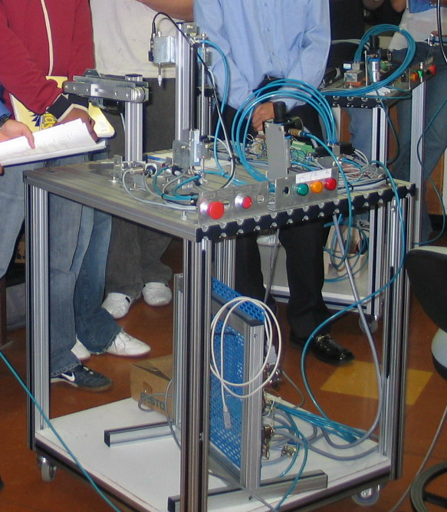
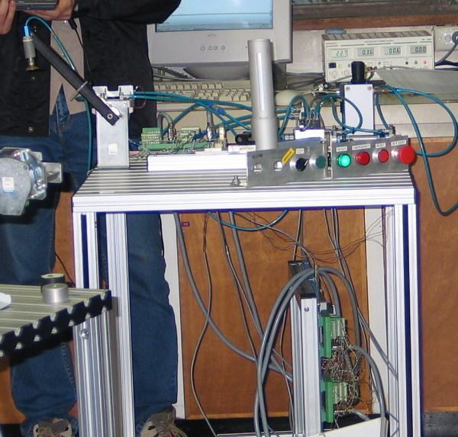
Figure 1: Two of the modular production systems used in the extended laboratory.

Students in groups of four or five will assemble the mechanical components of the modular system to perform a manufacturing process from a given specification. They will then test the mechanical functionality of the system and develop a control strategy to automate the system using a programmable logic controller (PLC). Wiring, programming and testing is done by the group. This may take up to 6 weeks spending 3 - 4 hours per week. The students will then describe and demonstrate the system to their peers as well as to any invited staff and answer any questions. The group will also present a report outlining the work done. The evaluation of the presentation was done both by staff as well as the students.

Since the extended laboratory work takes about 5 – 6 weeks and there are several tasks that need to be planned and executed, it was decided to incorporate some team work skills as part of the exercise. It was opportune that a web based system called TeamWorker was developed to manage team work by a member of the staff in 2002/2003 as part of a teaching fellowship (Murray, 2003). It was decided to use TeamWorker as part of this exercise as it provided a structured approach to team work. The TeamWorker provides a comprehensive team management tools with the following facilities for the students:
- Mandatory registration with the system
- A mandatory self evaluation exercise to sensitise students to their own skills in team work.
- Quick access to team members and staff via e-mail or phone
- Advice and guidance on how successful teams work and a step by step process for conflict resolution
- A peer evaluation, self-reflection and team reflection facility
- Ability to submit team’s goals and plans as well as meeting minutes
- Ability to view the records or evaluations entered by fellow team members
- Quick access to activity deadlines and planned meetings
- A chat room allowing online meeting if required.

Similarly TeamWorker allows the staff to do the following:
- Allocate students to teams in a variety of ways
- Set up activities for the teams and their members
- Inspect any or all entries which the students have made into TeamWorker
- Quickly generate status report

A short introduction to TeamWorker was given at the beginning of the semester well before the students were due to start their laboratory exercise. This included a short introduction to how to run meetings, record minutes, how to deal with loafers and conflict. The students were then asked to register and given a deadline to do so. The following activities were set up for the students as individuals and as a team to perform during the semester.
- Register and complete self-evaluation
- Set up a meeting and write out the plan to complete the MPS laboratory exercise
- Conduct and write minutes of the meetings
- Evaluate individually how the team is functioning
- Evaluate the role & behaviour of other team members (for staff view only)
- Evaluate the role & behaviour of other team members (for members to view)
- Self reflection on their experience in the unit as well as working in teams (staff view only)

These evaluations were progressively done with a time limit to complete each evaluation. Teamworker also contain information on how to deal with conflicts, how to conduct meetings etc. and the students are encouraged to read through these to deal with any situation that may arise in the group. Only in the event that a group could not come to an agreement, that the staff member will intervene and solve the conflict or problem.

Evaluation and Discussion

There are two objectives for setting up this extended laboratory exercise. First is to provide an authentic industry like project and the other is to develop team management skills. This exercise is an open ended problem with some missing information as one would encounter in Industry. Students are given only the likely outcome from the exercise and have to find out how to achieve this. This requires planning and careful execution. Thus, team management is an important aspect of the exercise. Before the use of Teamworker, there was no formal instruction or structured approach to manage a team was given to the students. Invariably, it was found that there was conflict and students struggle to complete the exercise as well as manage the team. The introduction of TeamWorker with a structured approach to team management, made it easier for the students to complete the exercises without the problems encountered by the past students. The students were given full control of the exercise.

The first task in Teamworker is to register and hold a meeting and plan the exercise in some detail. Again there are two aspects to this exercise: to learn how to conduct a meeting and to develop a plan with group members’ consent. An example of the key details of a team’s plan at the beginning of the exercises is shown below:

GROUP A (verbatim)
All group members have a productive and motivated attitude towards this project with all aiming to achieve close to full marks for the assignment. It is expected/taken-for-granted that we will all behave professionally to complete the task.
While we didn't really cover conflict resolution specifically in our first meeting, I think the general attitude was that while all of us have known each other for a while and are happy to work together, we will at no stage tolerate blatant laziness or poor quality work. Communication is via email or telephone which we were all more than happy about.
We broke the task into several main tasks but combining them into 5:
* Physical wiring of hardware and then recording of setup by creating schematic diagrams.
* PLC Programming

Tasks allocated for next meeting:
Names of Students in The Team | These are the tasks allocated to student to be done before NEXT meeting
Student 1 | Complete most of the physical wiring together of components
Student 2 | Create pseudo code for program
Student 3 | Begin report writing
Student 4 | Assist Alex with wiring
Student 5 | Create pseudo code for program. Minutes

GROUP B (verbatim)
All group members are to be present at meetings when required and contribute constructively to the meeting’s progress. All members are required to complete their assigned tasks before their deadline.
Any problems will be dealt with first by the whole group at a group meeting. If this is not possible the members involved will try to resolve the problem outside of group meetings or via email. Finally if this does not work the matter will be taken up with the lecturer.
By 5 April - Identify Input and Output Signals and how they are generated
By 5 April - Produce a wiring diagram for all electric and pneumatic circuitry
By 5 April - Develop Allocation Table for Inputs and Outputs
By 12 April - Produce pseudo code for the entire operation of the work-bench
On 12 April - Split the code into independent steps to be completed individually

Tasks allocated for next meeting:
Names of Students in The Team | These are the tasks allocated to student to be done before NEXT meeting
Student 1 | Produce a wiring diagram for all pneumatic circuitry
Student 2 | Produce a wiring diagram for all electric circuitry
Student 3 | Connect all sensors and actuators and test input / output signals
Student 4 | Develop Allocation Table for Inputs and Outputs
Student 5 | Produce minutes for last meeting and prepare an agenda for the next meeting

It can be seen from the notes above, that the students themselves have set the boundaries for the activities and guidelines on how to resolve any problems within the group. Further, Author observed that the groups worked together well and there were some lively discussions during the exercises. In a conventional laboratory exercise there is very little discussion among the students due to time constraints. It must be noted that there was no set time for the students to come and do the exercise. Each group decide when they want to work on the laboratory and how to complete the given exercise. Some of the comments made by the students during an informal feedback session on the exercise are very encouraging about the authenticity of the exercise.
“I have learnt a lot by doing this experiment”
“This assignment gave me confidence in working with tools and to program the PLC”
“This experiment, unlike other lab classes, made me think how things are done in the industry”
“The assignment gave us control in planning and execution”

The introduction of TeamWorker also allowed the students to comment on how they saw their role in the team as well as how others behaved in the team. This allowed them to reflect on their behaviour and to comment on whether there was a change in behaviour as a result of working in a team. A sample report from two students is given below.
Student 1 (Verbatim)
Our team has progressed well during this semester. Our meeting have been to-the-point and efficient. I think that this is due to the careful planning in the beginning of the semester, and the allocation of responsibilities to each member of the group. Another area that has been successful is the setting of a dedicated meeting time every week to follow up on everyone’s progress.
On the same note, I think that one area that improvement is on communications outside of meeting. Team members have become less vigilant in inform the other members of their progress through emails between meetings. This is somewhat understandable due to it being a very busy time of the semester; however it also means that if a team member encounters difficulties in their task, the problem is only addressed at the next meeting.
Having read two of the other team members responses, I would definitely agree with what they have said. I think that everyone has been extremely cooperative, and friendly. Its been a pleasure working with a team that you can trust things will “get done”. Go team!
I think that a good thing I brought to my team was my reliability, in that I was always present when I said I’d be present, and I completed what I said I’d complete.
Another thing I think I was good at was encouraging/motivating my team members to complete the required work.
Student 2 (Verbatim)
Something that I think I may need to improve is my lack of patience. I think it may have been better for my group if I was more patient with other team members, as it would have improved the team dynamics. And in future I think I will need to take a more active role in deciding who does what.

My team hasn’t voiced any opinions specific to me as yet, and so I feel I am unable to comment. If they said I was reliable, impatient and apathetic though, they’d be correct.
Student 3
To be perfectly honest, I haven't been as good a team member as I could've been. I relied too much on my other members and didn't contribute as much as they have. I intend to make up for this discrepency by doing additional work with regards to the report.

That said, I did make an effort to show up to every meeting, and to my knowledge completed the tasks assigned to me in each case. I restrained my natural urge to take over and order others about. No communications-breakdowns at least.

The opinions offered about me seem .... fairly accurate. Unfortunate but true, I'd rather spend twice as much time looking for a good shortcut than just sitting down and taking care of the allocated task.

In this extended laboratory exercise, presentation and demonstration forms part of the teamwork. Again as a group they manage the content and order of presentation. The only guide line given is the major areas to be presented. Figure 2 shows the involvement of the students in the presentation. It is noticeable that they take the evaluation of their peers seriously.

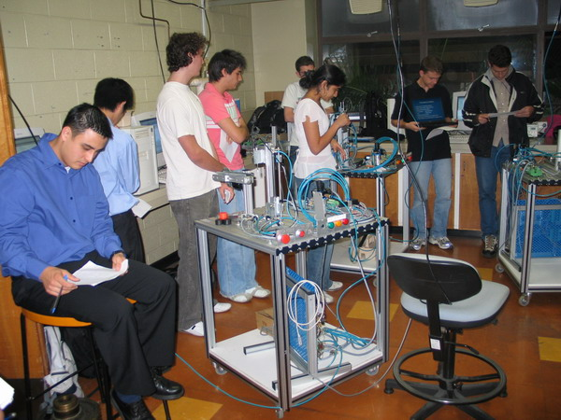
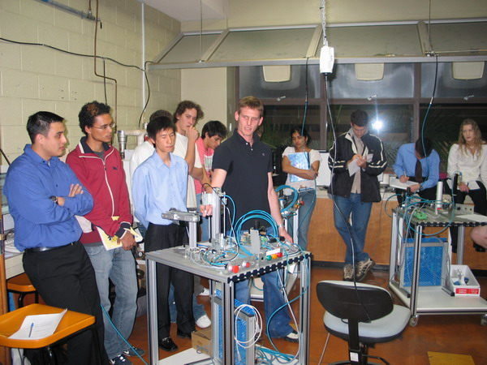

Figure 2: Presentation and demonstration of the completed MPS system.

Since the introduction of TeamWorker, author never had to resolve any conflict between members of teams. The above statements and others indicate that TeamWorker has helped them in planning, reflecting how they worked in the team and solved any team related problems. Thus it is reasonable to assume that the students have gained some of the team skills specifically how to conduct meetings, how to plan a project, how to resolve conflict and above all how to reflect on their own behaviour in the team. It was also noticeable at the confidence the students showed in their presentation. There is qualitative evidence that communication skills have improved as well.

CONCLUSION
It is evident from the way the students conducted themselves during the exercise as well as from their reflections that the extended laboratory exercise allowed them to solve open ended problems under environments similar to what they will encounter in industry. With full control of the laboratory exercise, students interacted with each other in the extended laboratory exercise than in any other short time group work situation in the university. The presentation and demonstration also helped them to improve their communication skills. Introduction of the web based online tool TeamWorker has helped the students to plan, reflect on their performance as a team member and to resolve any conflicts during the 5 – 6 week period of the exercise. The reflections of the students clearly indicate that they have recognised their strengths and weaknesses in working in teams. Further, the students have also suggested means to address some of the shortcomings in their behaviour. The School intends to improve on the existing extended laboratory exercises in the degree program.

REFERENCES

Asper,N.L. and Sepahpour,B. (2003) Utilizing Team Building Skills in Engineering Projects, Proc. American Society of
Engineering Education (ASEE) Annual Conference and Exposition, Session 2166.

Cunnigham.G. (2005) Developing Key Skills through an Authentic Design-Build Project, Engineering Subject

Centre, Higher Education Academy, 2005, http://www.engsc.ac.uk/er/key_skills/index.asp (Accessed 2, May 2005)

Institution of Engineers, Australia, (1996) Changing the Culture: Engineering Education into the Future,
Institution of Engineers, Australia.

Johnston.S. and H. McGregor.H (1998) Pedagogical Responsibility for Group and Teamwork, Waves of Change: 10th Australaian Conference on Engineering Education, Gladstone, Australia, pp 261 - 264, 1998

Jolly. L. and Radcliff.D. (2000). Strategies for Developing Reflexive Habits in Students, Proc. American Society
Of Engineering Education (ASEE) Annual Conference and Exposition, Session 1353.

Mildren.S., Whelan.K and Chappell-Lawrence.A. (1998), Introducing teamwork as a Teaching and Learning
Paradigm in Engineering Education, Waves of Change: 10th Australasian Conference on Engineering Education, Gladstone, Australia, pp 27 – 32, 1998

Murray.M.H. (2003), Managing Team Work online, OLT 2003: Excellence: Making Connections, Brisbane,
Australia, pp63 – 70, 2003.

Sepahpour,B. and Chang,S. (2005) Valuable Lessons from the Success and Failures of Teams of Engineering
students.Proc. American Society of Engineering Education (ASEE) Annual Conference and Exposition, Session

Shuman.L.J., Besterfield-Sacre.M. and McGourty.J. (2005) The ABET “Professional Skills” – Can They be
Taught? Can They be Assessed? Journal of Engineering Education, Vol. 94, Jan 2005, pp41 – 55

Smith.C., Armstrong.S and Tait.S (2003) LTSN Engineering Mini-Project Report: Enhancing Development in
Transferable Skills Group Projects through use of Training Exercises, LTSN, 2003
http://www.engsc.ac.uk/er/resources/index.asp?look=transferable+skills (Accessed 2, May 2005)

Yost,S., Lane,G. and Blanford,G. (2006) RATS: Students Working in Teams: Do they Really Benefit? Proc.
American Society of Engineering Education (ASEE) Annual Conference and Exposition, Paper 11665.

