A Learning Oriented Innovation for Graduate Work Preparedness

Tony Sahamaª, Adekunle Oloyede^{b} and Prasad KDV Yarlagadda^{b*}
ªSchool of Information Systems, Faculty of Information Technology,
^{b}School of Engineering Systems, Faculty of Built Environment and Engineering,
Queensland University of Technology, PO Box 2434, Brisbane 4001, Queensland.
*y.prasad@qut.edu.au

Abstract: Active cooperative learning Designs (CLD) represent a paradigm shift when preparing students for smooth transition to the work environment and lifelong learning in general. Often, cooperative learning can be time consuming, and can be designed and implemented inappropriately due to procedural inadequacies in the format of the supporting university-industry collaboration plan. This paper discusses some of the practical issues associated with a particular cooperative learning innovation, namely, Co-operative Education for Enterprise Development, that has been adopted at the Queensland University of Technology for final year Engineering and Information Technology, Coursework and Research Masters’ students to exposure them to the work environment and industry culture.

Keywords: Cooperative Learning Designs (CLD), Work Preparedness, Lifelong Learning, Industry Interaction, Co-operative Education for Enterprise Development (CEED)

Introduction

Rapid changes in the Science, Engineering and Technology fields, new and rapid developments in technology have rendered it impossible for classroom and laboratory teaching and learning alone to adequately prepare new graduates for work, innovation and creativity, and lifelong leaning in general. In this new environment, it has become increasingly challenging for institutions of higher learning, and in particular universities to continue to meet industry’s demand for task driven professionals, thereby necessitating a rethink on how to match what is taught with how it is taught; and how the quality of outcomes responds to the expectations in industry. The period of “teaching for test” syndrome is over. In order to make our graduates competitive, we must face the demands of this paradigm shift of the day and implement appropriate responsive changes.

The degree of change required is forcing all academic institutions, organisations, not just the industry world over, to re-visit and re-evaluate the types of knowledge, skills, abilities, and personality traits that potential employees must possess in order to assure their quality of input and contribution to today and tomorrow’s workforce As academics we are engaged in preparing effective, resourceful and responsive workers of tomorrow who can make significant impact in the real world. With the gruelling changes towards the future we ought to be identifying the skill set required for students to thrive, not just survive, in the turbulent Science, Engineering, and Information Technology industries. These skills include learning how to learn, interpersonal skills (e.g, listening, working with others, writing styles), communication, personal management including time management, adaptability, effectiveness in groups, teamwork and a well-developed work culture. Consequently, the prompt delivery of appropriate skills set, determining what types of teaching methods (pedagogy), the types of assessment portfolio that should apply, and the system of assessment to be used have become an imperative. These necessary criteria constitute a clear message that is commonly ignored, overlooked and/or inadequately addressed by many educators, as the higher education teaching environment continues to change rapidly. We as academics contribute to this change in different ways while at the same time there seems to be a lack of pace towards introducing alternative pedagogical learning models. The conventional lecture room model, tutorials and assignment recipes which are no longer popular amongst the majority of our students are examples of this attitude and approach.

Traditional lecturing mode with the lecturer in front of the class is a learning design with which we academics are comfortable and it is no doubt effective in what it is meant to achieve, namely content delivery dissemination of facts (Information) and it will undoubtedly remain a primary component of educating Science, Engineering and Information Technology students. However, it is now a commonly held opinion in many responsive institutions around the world that the effectiveness of this conventional teaching and learning design/tool can be greatly enhanced by reshaping it to suit the cooperative learning environment [1-9], with laboratory practicals supporting learners in the active CLD domain.

Cooperative Learning and Design (CLD)

The CLD is not a new idea, and many educational institutions, schools and professional disciplines use this learning environment around the globe [10-13]. The cooperative learning approach has been defined by Cohen [14] as "students working together in a group small enough that everyone can participate on a collective task that has been clearly assigned. Moreover, students are expected to carry out their task without direct and immediate supervision of the instructor." Therefore, cooperative learning can assist trainees in becoming less dependent on teacher instruction and more responsible for their own learning [15]. The cooperative learning approach is characterised by procedures such as communicating a common goal to group members, offering rewards to participants for accomplishing their group's goal, assigning roles to individuals within each group, and holding group members accountable for their individual performances [16]. The success of cooperative learning techniques is evidenced by the higher academic achievements of participants; which include increased students’ self-esteem, and improved interpersonal relationships [17]. Newmann and Thompson [18] found that 68% of the 37 studies evaluated by them reported more positive outcomes from cooperative learning than traditional forms of instruction. Johnson, et al. [19] also noted the positive consequences of the cooperative learning environment. A meta-analysis of studies done on undergraduates in science, mathematics, engineering, and allied health technology showed that students who learned in groups demonstrated greater achievement than students who were exposed to instruction without group learning [16]. Rossetti and Nembhard [20] simulated CLD in the classroom, and concluded that the use of CLD in the classroom resulted in a better outcome for students with respect to increased degree of interaction, communication and academic inquiry, with improvement in their thinking and problem-solving skills. Furthermore, their study suggested that for “professional engineers, the ability to actively identify, formulate, and solve problems essential for a successful career was met through CLD”. A recent study on using cooperative learning techniques in a Computer Science course conducted by Beck et al. [1] indicated that there were substantial educational benefits for the students who took part in CLD. Furthermore, the same study suggested that students in the cooperative learning environment performed substantially better in the final examination in comparison to the students who did not participate in cooperative learning.

While the above present the rationale, definitions, examples and attributes of cooperative learning and the appropriate environment for this concept to thrive, none of the models described, addresses the need of the advanced stage professional education, such as cases where students aim to apply their accumulated theoretical knowledge to a large and focused problem of immediate need to an industry partner. Such interactions with industry at this stage, usually in the final year of their courses can contribute significantly to post-graduation job prospects with the company in which a student does his/her final year project. Students may also be hired in a similar company, or any non-related industry needing the skills of project management, interaction with industry, and the ability to embark on and complete a project of real value with little supervision, and more importantly the appreciation of work ethic and industry culture as distinct from those of the university environment. The Queensland University of technology caters for this final year exigency amongst other cooperative learning initiatives through its engagement in the Cooperative Education for Enterprise Development (CEED) program. The new CEED’s conceptual model used for placement of Research Masters students in industries is shown in Fig.1.
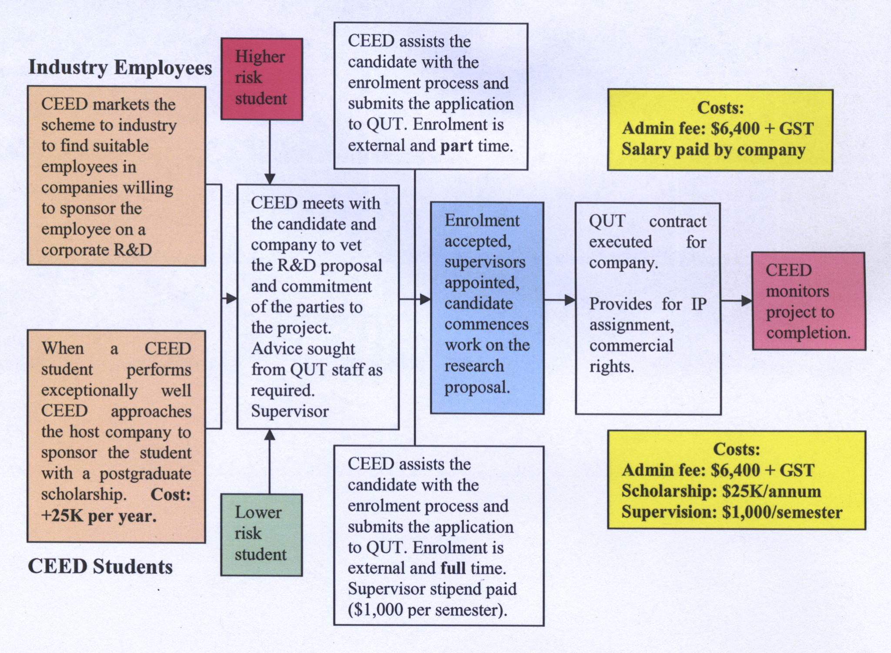
Fig. 1 CEED project model for placement of HDR (Masters by Research) students

The CEED Innovation

While cooperative learning approaches have been proven quite successful, it is important to realize that this method of learning is more than just "putting students in groups" and giving them assignments. The CEED program is a form of education where part or most the student's later year education is done with industry practitioners. This training is based on projects conducted on-site in industry or government departments. The project usually arises from a client's need to undertake Research and Development (R&D) or improvement in an area in which it lacks available personnel or resources. CEED provides companies, State and Local Government with a cost-effective alternative method to undertake developmental work, while enhancing students’ practical education content through involvement in real life projects. Of fundamental significance is that the project undertaken must be of sufficient difficulty and suitable scope to satisfy the requirements of a usual final year project and in accordance with the relevant professional body’s accredited aims and objectives of the final year project. This project could be at the honours or Master's thesis level, but must, unequivocally meet the corporate agenda of the participating company.

Projects are initially identified by the CEED Program Coordinator, and negotiated between the client and the relevant university’s school or departments. The projects are then advertised to students who have applied to partake in the CEED Program. The applicants are short-listed, interviewed formally by the client (industry partner) and selected on a competitive basis. Two supervisors are appointed to the project; one from the client organization and the other an academic from the school or department in which the student is studying. The project is supervised jointly and conducted on either the client or university premises depending on which best suits the task. The program currently provides projects for final-year undergraduate and postgraduate students in the fields of Engineering, Science (Mathematics) and Master of Information Technology, through QUT. Since its inception, CEED has successfully completed over 400 projects and the Program has gained a wealth of experience and reputation, as well as being a valuable resource to Queensland industries in.

Management and Quality Assurance of the CEED program

At QUT, the Office of Commercial Services (OCS) administers the CEED Program on behalf of individual Schools. The programme is coordinated by a committee of industry, university and student representatives. The committee is chaired by the manager of the OCS. Corporation Technologies Pty Ltd under contract with QUT administers the CEED Program. A director who was appointed in 1992 and charged with the task of sourcing opportunities for the training of senior undergraduate and postgraduate students in the industry environment. In addition, Marketing and Administration assistance joined Corporation Technologies in 2002, to provide the CEED programme more insight into access to the wider marketing campaigns around Brisbane. Sound management is a key aspect of the CEED Program. The Program Coordinator organises all introductions, conducts meetings and student interviews and liaises on behalf of the client organization. A system of co-supervision between the client and university ensures that the parties are in regular contact throughout the project. Students are assisted with training in project planning and management and the Coordinator is available to advise industry on plans for development. CEED also has a Quality Management System in place, which monitors the progress of each student at critical points along the way, to ensure that projects’ outcomes and client expectations are met. The CEED Program consistently delivers at least 95% client satisfaction level, across all projects.

Types of CEED projects
At the QUT, CEED currently offers projects in the following areas: Mechanical Engineering and Manufacturing, Electrical & Electronics Engineering, Civil Engineering, Infomechatronics, Applied Science (Mathematics), Masters of Engineering Management (MEM) and Master of Information Technology. On occasions, the CEED program has also offered projects in areas such as Business (Marketing and Accounting), Human Resources and Geology. The type of projects suitable to CEED students are varied, including, but not limited, to Operations Research, manufacturing/business process modelling and improvement, product development, finite element analysis, industrial plant relocation/layouts, industrial design, quality assurance program implementation and audits, quality improvement, statistical analysis, monitoring & reporting, manufacturing, preventative maintenance programs, prototyping, electronic product research and development, software development, knowledge management, e-commerce software applications, wireless applications, web-based software applications, database development, data warehousing and data mining.

Student eligibility for a CEED projects

The CEED Program receives registrations and applications for projects from both Domestic and International students, currently studying at QUT. To be eligible for a CEED project, students must be enrolled in the FINAL year of their undergraduate degree is the university. The project is usually worth the equivalent of a number of credit units namely 24 credit points or 4 units (= 3 days/week), 6 units/36 credit points (= 4 days/week), 48 credit points (= 5 days/week). Flexibility of working hours/days around examination time can be negotiated with the industry supervisor(s) to ensure that students are not disadvantaged.
Students’ time commitment to CEED Project
Courses are specifically designed and timetabled to allow students to undertake full-time or significant levels of part-time work on the client's premises. The majority of projects are conducted over 1 semester (13 weeks) with a small number of part-time projects extending to a second semester. Students are required to spend a minimum of 3 days per week (around 20hrs/week) working on their projects, throughout the semester on-site at the client's premises, and can use university resources such as testing facilities, library, specialist software, etc. The time varies according to the allocation of credit points/units for the project (i.e. 24 credit points or 4 units = 3 days/week, 6 units/36 credit points = 4 days/week, 48 credit points = 5 days/week). The students are not allowed to overload themselves by exceeding the maximum semester 48 credit points stipulated for a full semester’s load when undertaking a CEED project. For example, if a CEED project is worth 24 credit points, a student would only enroll in a maximum of 2 other subjects during the same semester. If project is worth 36 credit points, the student would enroll in only 1 other subject. On the other hand, most students are aware that industry-based projects might require them to commit more time than when engaged in coursework subjects in order to successfully complete the work and provide customer (industry) satisfaction. This disparity in time commitment between coursework and CEED project load is compensated for by paying students a stipend over the period of the project. The terms of each project and value of scholarship are advised to students at the time of advertising the project.

Discussion

Program quality

In 2003, over 75% of CEED students were awarded a Distinction (grade 6) or a High Distinction (grade 7) for their projects. These results clearly demonstrate the high standard generally achieved by students undertaking CEED projects. These grades were achieved irrespective of the students' Grade Point Average (GPA) upon commencement of the project. The GPA of CEED students usually range from low 4s to high 6s (on a scale of 1-7, where 1 is lowest and 7 is highest) - as there is no minimum GPA requirement for eligibility. The summary of student grades for 1st Semester in 2003 is shown in Fig.2

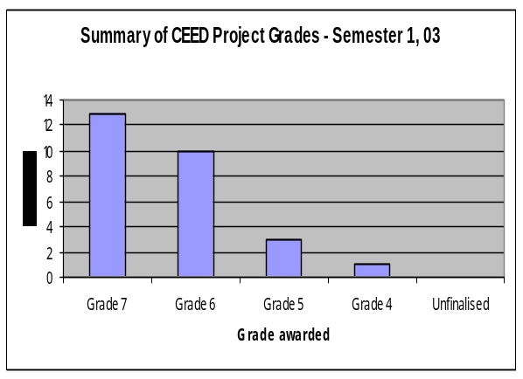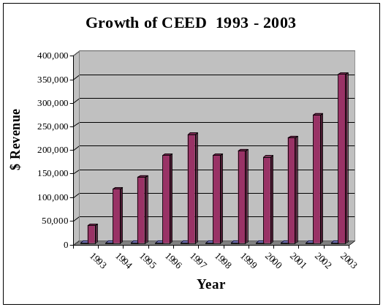
Fig.2 Summary of Student Grades Fig.3 Growth of CEED Project Scheme

Success of the CEED program

The CEED initiative is approaching its 14th year in South-East Queensland as a well-established industry affiliated program providing a positive interaction between University and Industries not only around Brisbane but also right up to the far north of Queensland (e.g., Bundaberg and Harvey-Bay). . The growth of CEED project scheme over past decade is shown in Fig.3. By summer 2006, the CEED programme will celebrate its 500th industry project. Since 1992, the CEED program has generated considerable revenue as shown in fig.4, while benefiting industry R &D. This is a significant achievement and the growth is increasing every year. Furthermore, majority of students who have participated in the program have been supported both financially and professionally leading to remarkable achievement. Around 50% of CEED projects resulted in either full time and/or part time employment to students. A recent survey conducted by the CEED administration among participating industries and students supports this claim to CEED’s success. This is encouraging and demonstrates the viability and responsiveness of this collaborative learning environment in achieving work preparedness by students. Most of the industries stated that this program is a “Win-Win-Win” situation for all the parties involved

Benefits of CEED to the industry clients

CEED is always seeking to increase its range of services to students, to help manage the transition between the lecture room and full-time employment, by offering meaningful industry projects, which promote students' professional development. Students continually cite their industrial training as a major influence in their preparation for employment and early professional development. The CEED experience has shown that industry and government can play a vital mentoring role to senior tertiary students at QUT.

The benefits to industry and government departments include:
- Ownership of the project results (and intellectual property)
- Access to university staff and physical resources, in a routine and businesslike manner
- All projects are covered by contract with QUT, which means that regardless of the students’ performances the project must be completed to the satisfaction of the client
- Projects are carefully monitored by co-supervision.
- Organisations are readily able to realign work and processes regularly, to remain competitive in their industry.
- Expenditure may be claimable under the AusIndustry 125% R &D tax concession scheme, designed to encourage industry R&D programs.
- CEED provides an excellent method for selecting future employees.
Benefits to students and university at large
Overall students who participate in the CEED program usually benefit from contact with prospective employers and hands-on learning in an industry environment. The specific benefits of this program can be classified into 3 categories as discussed below.
Academic benefits: Many students, especially those with average academic records are able to demonstrate first hand to employers their capabilities in performing individual and group tasks to schedule, and with significant levels of accuracy. Since its inception only 6%, on average, of the projects undertaken have been uncompleted or below standard. Because of the nature of the tasks the students are able to learn how to work in a collaborative manner cooperating between industry and university personnel most of the time managing the relationships and flow of information in order to complete their projects successfully. Over 40% of the students earn high distinction in their assessment which consists of both written and oral presentations. Another 30% obtain distinction while close to 10% earn credit. These levels of achievement are spread over the range of student academic abilities with respect to performances in formal examinations. Anecdotally, it can be observed that the satisfactory completion of the challenging projects of real world industry relevance usually results in a significant boost to students’ self esteem and belief in self.
Financial benefits: All students undertaking CEED projects earn a bursary which contributes to the relief of some of the pressure of working to earn their sustenance while completing their final year projects at the same time especially in a non-related field and environment to their immediate professional aspirations. Presently, students earn $3,000 over the 14 weeks of the project in bursary.
Occupational benefits: Many of the students find immediate employment with their CEED companies, while others secure jobs in related companies. Overall, students develop a keen appreciation of the industry environment and expectations and the confidence which contribute to success in employment interviews. The work/industry environment is usually demystified after their CEED experience. Owing to the associated demand of performance on their projects students usually end up developing a high level of dedication and work ethic including the appreciation of the fact that completing a task to a high standard is not usually a 9 to 5 job!
University benefits: This CEED project scheme has assisted university academics to develop close relationships with industries and provided them a better opportunity to understand the needs of industry, while and delivering the short term requirements of SMEs in Queensland. In addition, it has also assisted in identifying and establishing long term relationship with industry partners in order to support their on-going research funding, developing joint research grant applications to various State and Commonwealth funding agencies such as Australian Research Council, Smart State funding, Innovation and Infrastructure grants and various international funding organizations such as ADAB, World bank, European, Union and other international organizations. The income generated from the CEED projects scheme during the past decade is shown in fig.4.

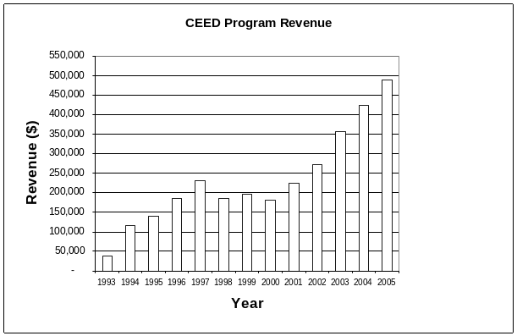
Fig. 4: Revenue to QUT through CEED Scheme

Conclusions

The CEED programme has proved to be a workable model of cooperate learning and has delivered significant benefits to the three partners involved namely; students, industry partners and university academics. It has been able to provide an alternative avenue for students to build skills and engage in real world projects of value to industry and the wider community. It has provided a vehicle for integrated learning and work readiness for both undergraduate and postgraduate students. Financially it has proved rewarding to students, industry and university. It is envisaged that the CEED program could be expanded to include doctoral research training, which may involve both domestic and international industries and research organisations.

Finally, we note that this scheme has provided an affordable research and development support for industry, especially the small to medium enterprises, that otherwise would have been unable to fund and support their developmental requirements for growth.

References
1. Beck, L.L., Chizhik, A.W. and McElroy, A.C. (2005). Cooperative Learning Techniques in CS1: Design and Experimental Evaluation. ACM SIGCSE Bulletin 37(1): 470-474.
2. Crow, C. (1997). Cooperative Education in the New Millennium. Cooperative Education Experience. Columbia, MD; Cooperative Education Association (Ed 414 433) pp 1-5.
3. Finn, K.L. (1997) . The Spaces Between: Towards a New Paradigm for Cooperative Education. J Cooperative Education, 32, 2, pp 36-45 (EJ542 265).
4. Freeland, R.M., Marini, R.C., and Weighart, S. (1998). Moving Partnerships between Co-op Institutions and Co-op Employers into the Next Century. J Cooperative Education, 33, 2, pp 17-27.
5. John, J.E.A., Doherty, D.J., and Nichols, R.M. (1998). Challenges and Opportunities for Cooperative Education. J Cooperative Education, 33,2, pp10-16.
6. Van Gyn, G.H. (1996). Reflective Practice: The Needs of Professions and the Promise of Cooperative Education. J. Cooperative Education, 31, 2-3, pp 103-131 (EJ 524 110).
7. Varty, J.W. (1994). Cooperative Educationfor the ’90 and Beyond. Co-op/Expereince/Co-op 5, 1, pp10-11. (EJ 478 859)
8. Wilson, J.W., Stull, W.A., Vinsonhaler, J. (1996). Rethinking Cooperative Education. J Cooperative Education, 31, 2-3, pp. 154-165. (EJ 524 112).
9. Fellers, J. W. (1996): Teaching Teamwork: Exploring the Use of Cooperative Learning Teams in Information Systems Education. The DATA BASE for advanced in Information Systems, 27(2): 44-60.
10. Lemckert, C.J. (2003). A coastal engineering industry affiliates programme model to enhance student learning. World Trans on Eng and Tech Educ., 2, 3, pp417-420.
11. Furco, A. (1996). Service Learning and School-to-Work. J Cooperative Education, 32, 1, pp7-14.
12. Fink, F.K.(1999). Project Organised Problem Based Learning in Engineering Education – 25 years of experience. Proc. 4th European Forum for Continuing Engineering Education. Tronheim, Norway.
13. Mckee, W.A. (1999). Integrating education and industry through enhanced projects. Global J. of Engrg. Educ. 3, 3, pp 287-289.
14. Cohen, E.G. (1994). "Restructuring the Classroom: Conditions for Productive Small Groups," Review of Educational Research, Vol. 64, No. 1, pp. 1-35.
15. Ryan, S. D., Bordoloi, B. and Harrison, D.A. (2000). Acquiring Conceptual Data Modeling Skills: The Effect of Cooperative Learning and Self-Efficacy on Learning Outcomes. Te DATA BASE for Advances in Information Systems, 31(4) 9-24.
16. Springer, L., Stanne, M.E., and Donovan, S.S. (1999), "Effects of Small-Group Learning on Undergraduates in Science, Mathematics, Engineering, and Technology: A Meta- Analysis," Review of Educational Research, Vol. 69, No. 1, pp. 21-51.
17. Slavin, R.E. (1983). "When Does Cooperative Learning Increase Student Achievement?" Psychological Bulletin, Vol. 94, pp. 429-445.
18. Newmann, F., and Thompson, J.A. (1987). Effects of Cooperative Learning on Achievement In Secondary Schools: A Summary of Research, Madison, WI: University of Wisconsin-Madison, National Center on Effective Secondary Schools.
19. Johnson, D.W., Johnson, R.T., and Smith, K. A. (1991). Cooperative learning: Increasing college faculty instructional productivity. ASHE-ERIC Higher Education Report. No. 4. George Washington University.

20. Rossetti, M.D and Nembhard, H.B. (1998). Using Cooperative Learning to Activate Your Simulation Classroom. Proceeding of the 30th Conference on Winter Simulation, Washington, D.C. (USA), pp. 67-76.

