Complete the table below for your submission (individual or team).
Name | Role  (e.g. Engineering academic, engineering professional or technical staff, engineering student, industry engineer, or other - please specify) | Contribution to the project  (Each member must contribute at least 10% to the body of work, with engineering staff, engineering professional or technical staff, and engineering students contributing at least 50% to the work in total.) | Current AAEE member? (Y/N)  Current AAEE membership is required only for engineering academics, engineering professional or technical staff, and engineering students.
<Person 1> | Engineering academic | 40% | Y
<Person 2> | Engineering professional staff | 20% | Y
<Person 3> | Engineering student | 20% | Y
<Person 4> | Industry engineer | 20% | N

Membership screenshot
For each person marked ‘Y’ against the “Current AAEE Member?” column above, provide a screenshot of the EA website displaying their name and “Active” status for the current year with AAEE. The relevant page can be retrieved by:
- Going to https://portal.engineersaustralia.org.au/home
- Clicking on “My EA”
- Clicking on “My Technical Society Membership(s)”
- Taking a screenshot of the page redacting your EA ID and any irrelevant information. Example below.
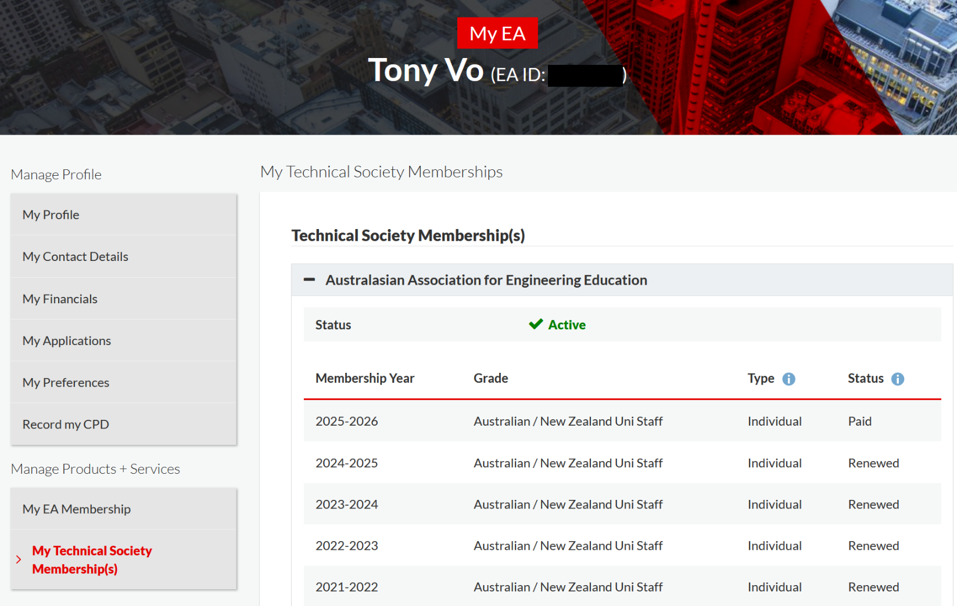
<Person 1> – insert screenshot here

<Person 2> – insert screenshot here

<Person 3> – insert screenshot here

